Guidelines for Authors
Alpha A. Beta*¹, Charlie D. Echo² and Frith G. Hadley³
¹ Clean Air Department, University of Clean Air South Africa, a.beta@blog.com.za (ORCIDID)
² COMPANY NAME, Post Office Box 999, Kampala, Uganda, 58376, charlie@company.com.ug (ORCIDID)
³ COMPANY NAME, Post Office Box 999, Kampala, Uganda, 58376, charlie@company.com.ug (ORCIDID)
The abstract must convey the main results and conclusions of the article. Abstracts should be no longer than 300 words. This paper is written in the required format to provide a model. Authors are encouraged to download the document and use it as a template. The Title is to be centred at the top of the page in Bold Arial size 12. Leave a 2.5mm (7 pt) space between the title and authors. The list of authors should be centred in Arial, size 11. First name, middle initial and surname should be given for each author. The names of authors should be separated by a comma. A numerical superscript following each author name should be used to reference the affiliation of each author. The corresponding author should be indicated with an asterisk (*). Affiliations should be in Arial size 9 font, and include postal address and email address of each author. The abstract should follow in Arial size 11. Manuscripts should be submitted as a word document.
Keywords: Include up to two lines of keywords, leaving 3 mm (9 pt) space above and 7 mm (20 pt) space below.

Page Format

Paper Layout
Margins should be as follows: top 25mm; bottom 30mm; sides 20mm; space between columns 8mm. The abstract is indented an additional 10mm from the left and right paper edges.
Use a single column down to the end of the Abstract, then leave 7mm (20pt) space below and use two columns for the rest of the paper (except for any unavoidably wide tables or illustrations).
Do not number the pages.

Type Specifications

Headings
Heading specifications are as follows:
- Paper title: 12 pt Arial font, bold, centred.
- Authors’ names: 11 pt Arial, sentence case, spaced 2.5mm (or 7 pt) beneath the title.
- Authors’ affiliations and addresses: 9 pt Arial.
- Main section headings: 11 pt Arial bold, numbered, sentence case, left justified. 14 pt space above and 3 pt space below.
- First-level subheadings: 11 pt Arial, numbered (with hanging indent), sentence case, left justified. 10 pt space above and 3 pt space below.
- Second-level subheadings: 10 pt Arial italic, numbered (with hanging indent), sentence case, left justified. 7 pt space above and 2 pt space below.

Here is an example second-level subheading
Some text below the subheading.

Body Text
- 10 pt Arial, justified, first line indented 4mm.
- Fully justify each line, hyphenating if necessary.
- Insert only a single space after a sentence.
- Avoid hyphens at the ends of two or more consecutive lines.
- Use bullets similarly to here, with the minimum spacing between them to provide clear separation.
- Avoid widows and orphans.

Content

Title
The title should be as concise as possible - generally no more than two lines.

Abstract
Do not exceed 300 words. Include the main purpose of the paper and the principal conclusions.
End the abstract with a list of keywords, as shown in the example above.

Notation
If necessary for clarity, you may include a glossary of mathematical symbols etc. under an unnumbered heading ‘Notation’ before the main text.

Body of the Manuscript

Units
Use SI units wherever appropriate.

Equations
Number all equations at the right edge of their column.
Equations should fit in a single column, even if they span two lines.

Illustrations
For submission of manuscripts, all illustrations and figures should be inserted into the main body of the text. Illustrations and figures should mostly fit in a single column, as below. All illustrations should be referred to in the text, as in the case of this reference to Figure 1. A numbered caption in 10 pt Arial type should be placed below each illustration, as in the example above. Captions should be concise, leaving full explanation to the text, yet contain enough information that explains the figure. The width of text should be at least 10mm narrower than the full column. Captions with more than two lines usually look better as justified text rather than centred
Upon submission of the final accepted manuscript, Figures should be submitted as separate files and not included in the body of the text. For the production of the accepted manuscript they should be submitted as separate files in *.pdf, *.ps, *.eps, *.jpg, *.png, *.tif, or *.gif format with a resolution of not less than 150-300 dp. All illustrations and figures can be printed in colour.

Tables
Tables may span one or two columns. If necessary, a large table may be presented in ‘landscape’ orientation, i.e. rotated with the top of the table on the left-hand side of the page.
Table captions should be at the top of each table, but otherwise conform to the specifications for illustrations.

Citations and List of References
Please take great care to ensure references are properly and fully included in your manuscript. They are the most common source of drafting faults in papers.

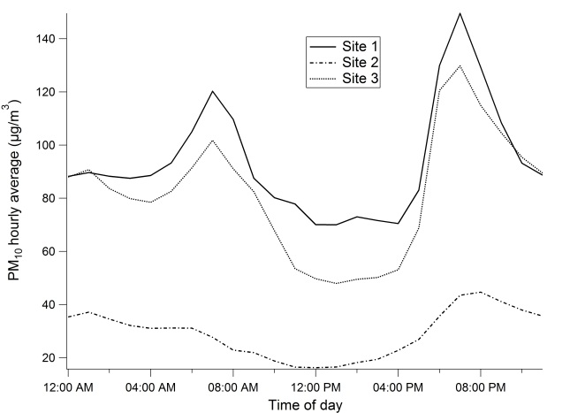Figure 1. Example illustration. PM₁₀ mass concentration versus time of day for site 1 (solid line), site 2 (dotted line) and site 3 (dashed line).
The Harvard system (AGPS 1994) should be used for citing publications in the text and listing their details at the end of the manuscript. A brief summary follows:
Generally, a textual citation requires only the name of the author (or authors) and the year of publication (with no comma between the two). Page numbers may be included where appropriate, as in ‘Milligan (1955, pp. 245-7)’.
Citations may be made by referring to the authors in mid-sentence, as in Sellers and Secombe (1957, 1958a, 1958b) or Milligan et al. (in press), but should preferably appear at the end of the sentence as here (Secombe and Sellers 1956, Milligan 1961).
The term ‘pers. comm.’ should not be used. Contributions of this kind should appear in an Acknowledgment at the end of the paper.
All references cited should be listed at the end of the paper (or prior to any Appendix, if included). See the ‘References’ section of this paper for examples of listing references. More detail is provided by AGPS (1994) or may be found at http://en.wikipedia.org/wiki/Harvard_referencing.

Submissions
Please submit all documents in word document.

Permission to Publish
The author is responsible for all material contained in the manuscript they submit. Co-authors must agree to the submission of the paper.
It is the author’s responsibility to inform the journal the manuscript has been published or offered elsewhere. It is also the author’s responsibility to obtain clearance to submit material in which any other party has a legal interest (e.g. employer, funding body or client).

Acknowledgments
Acknowledgment by the author of the use of material from an outside source is a condition of such use, as well as a courtesy. Wherever possible, it should be made not only in the acknowledgments section but also at the place or places in the text where the material is included.

Author Contribution
A summary of the contribution made by each of the Authors

References
See Section 3.4.5 for rules of citing and listing references. Note the use of hanging indents below. Double quotation marks should only be used within single quotation marks.
AGPS (Australian Govt Publishing Service) 1994, Style Manual for Authors, Editors and Printers, AGPS, Canberra.
Baker R. 1995, ‘Risk management and risk assessment in air quality standards setting’, Clean Air (Aust.) 25:62-7.
Dahl R. 1986, Two Fables, ill. G. Dean, Viking (Penguin), Harmondsworth.
Kuschel G. and Foster E. 1996, ‘The Christchurch emissions inventory as an air quality management tool’, Proceedings of the 13th International Clean Air and Environment Conference, Adelaide, 1996, Clean Air Society of Australia & New Zealand, Eastwood, NSW, Australia, pp. 180-185.
Milligan T.C., Secombe H. & Sellers P. 1986, ‘Particle Pollution in Woy Woy, NSW’, Clean Air (Aust.) 145:233-8.

Appendix
This is where you would insert any appendix. Multiple appendixes should be labelled A, B, C, ….

